16. Write a C program that can perform a letter frequency attack on any monoalphabetic substitution
cipher without human intervention. Your software should produce possible plaintexts in rough order of
likelihood. It would be good if your user interface allowed the user to specify “give me the top 10
possible plaintexts.”
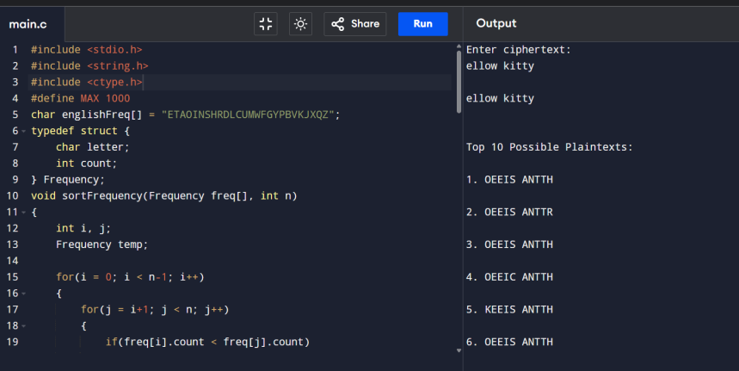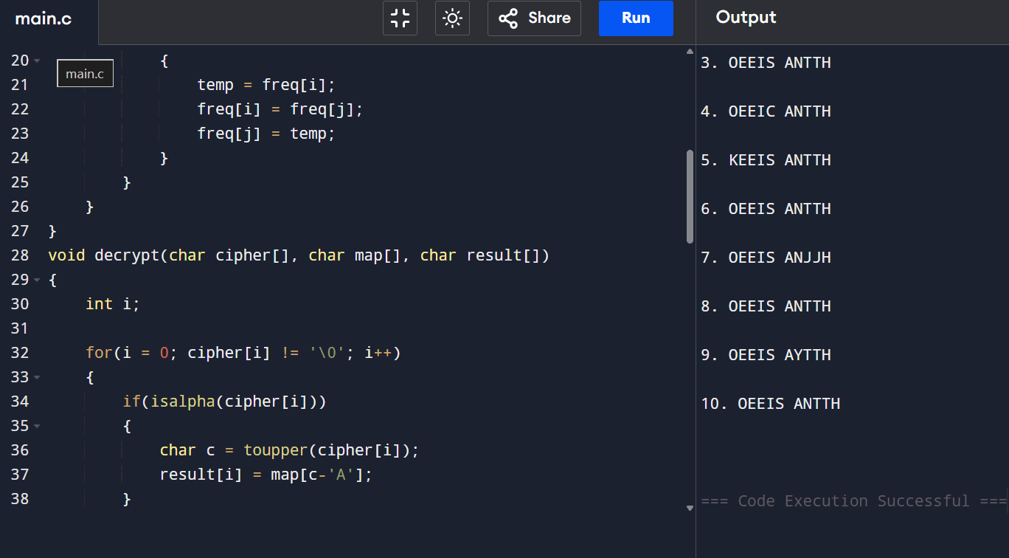
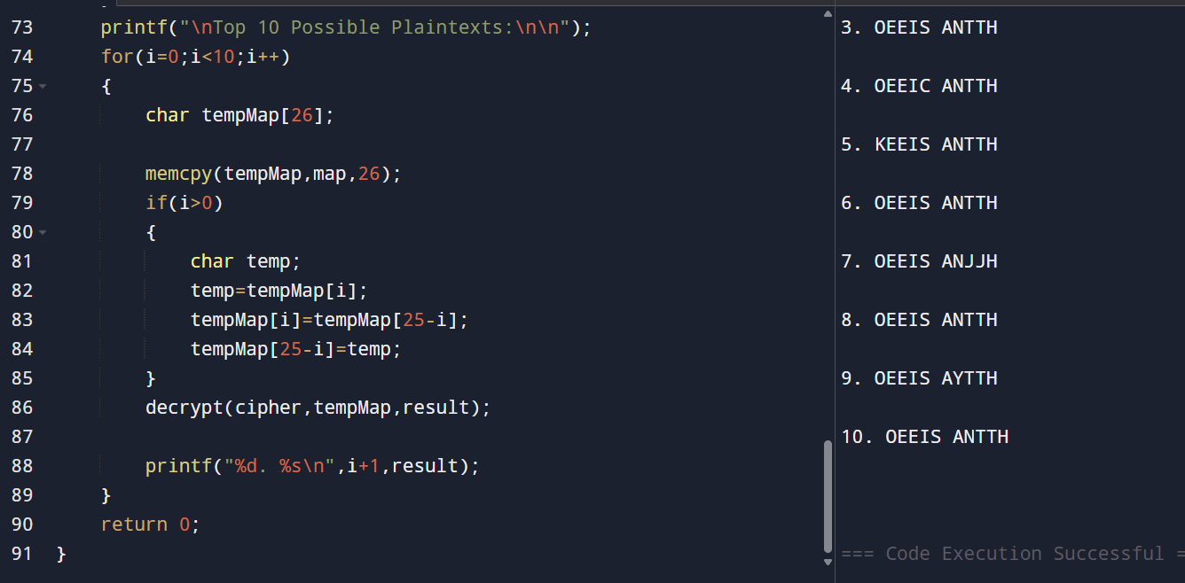

17. Write a C program for DES algorithm for decryption, the 16 keys (K1, K2, c, K16) are used in
reverse order. Design a key-generation scheme with the appropriate shift schedule for the decryption
process.
PROGRAM
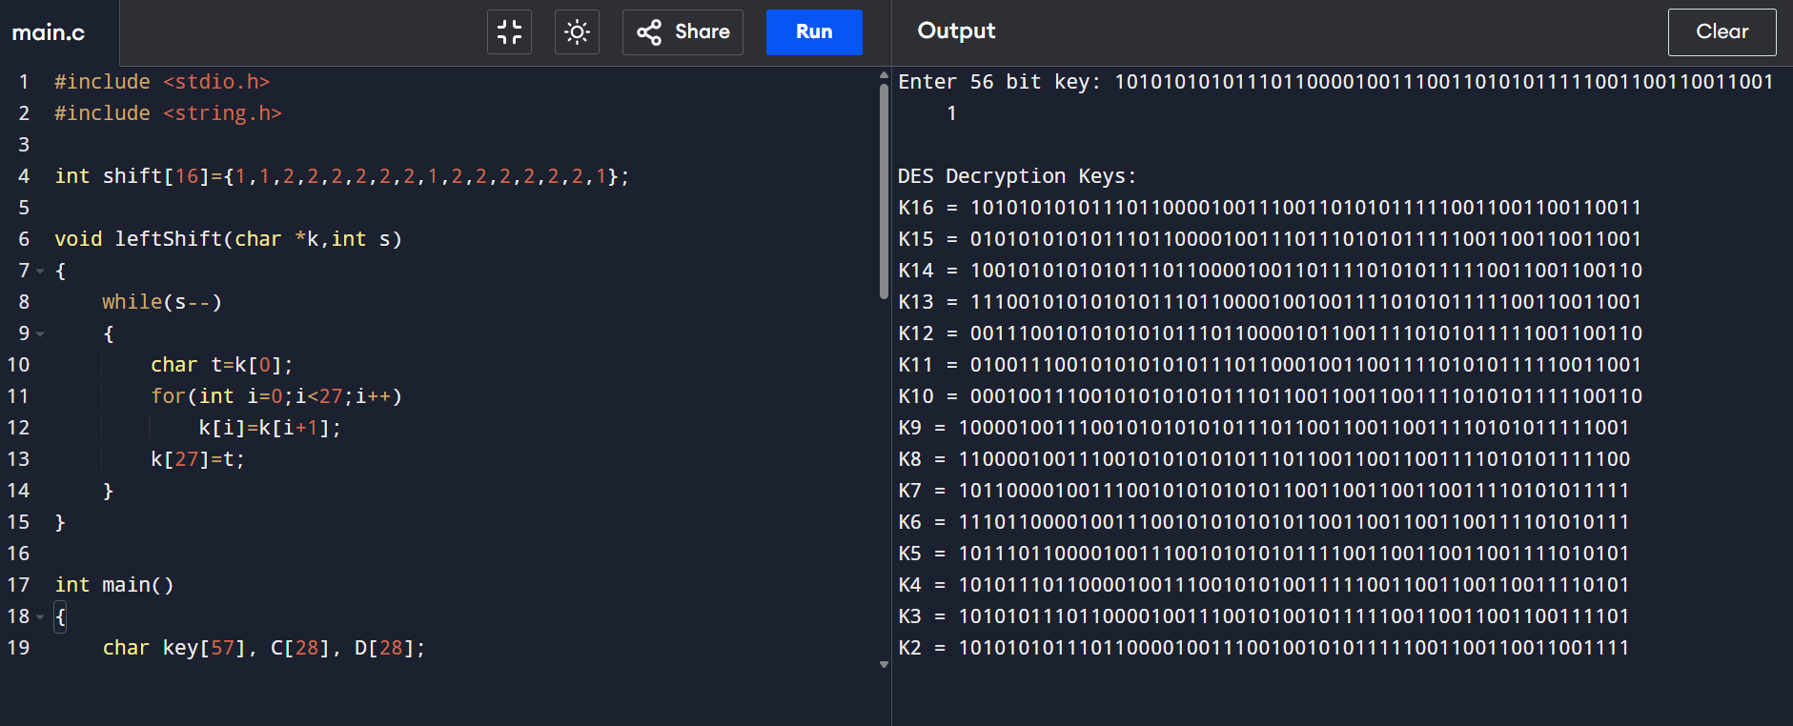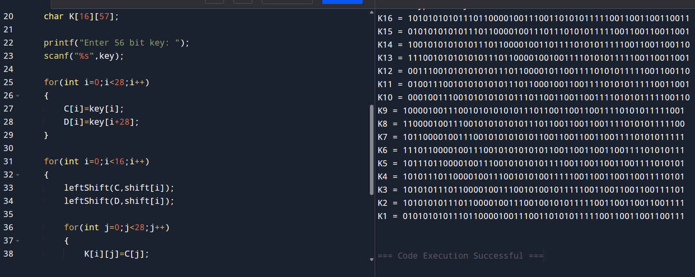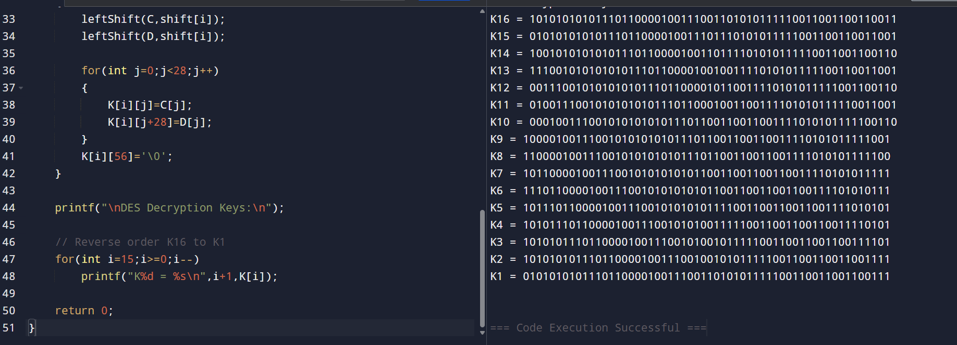

18. Write a C program for DES the first 24 bits of each subkey come from the same subset of 28 bits of
the initial key and that the second 24 bits of each subkey come from a disjoint subset of 28 bits of the
initial key.
PROGRAM
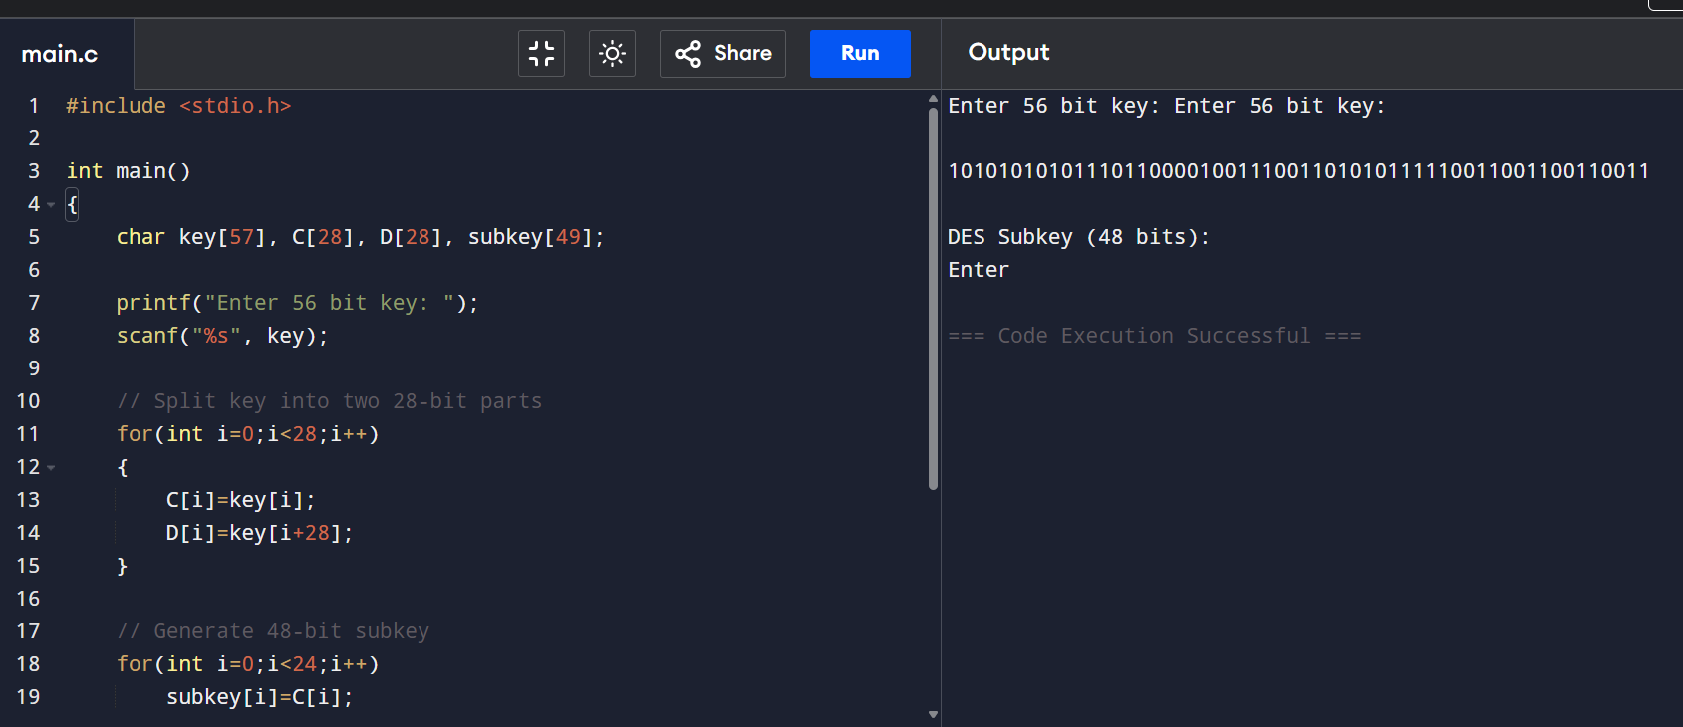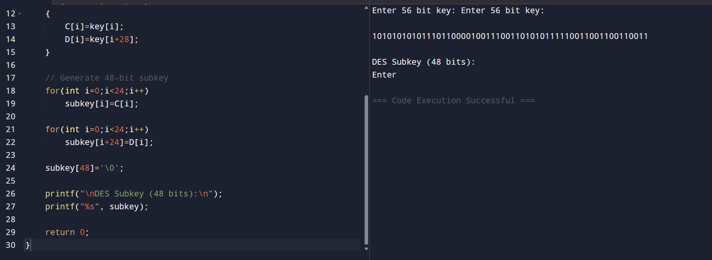

19. Write a C program for encryption in the cipher block chaining (CBC) mode using an algorithm
stronger than DES. 3DES is a good candidate. Both of which follow from the definition of CBC.
Which of the two would you choose:
a. For security?
b. For performance?
